**MIND STORM SOFTWARE PVT LTD**

**Hands-On Exercise – ex02.doc**

**Objective**Basic UI in Android and View Handlers

**Assumptions**

* Development Environment for Android (Java SDK, Eclipse, Android SDK) has been setup successfully.
* You are familiar with using Eclipse.
* Android SDK 2.3.3 is available and Android Virtual Devices are already created.
* Start the Android Virtual Device to save time.
  + Click on **Window 🡪 Android SDK and AVD Manager**.
  + Select an **Android 2.3.3** compatible AVD and click on **Start**
  + Select **Scale display to real size** and provide a **Screen Size (in)** as **5 inches** or any other appropriate size for your development machine.

**Step by Step Instructions**

**Step 1 – Create the Android Project**

1. Create a new project. Click on **File🡪New 🡪 Android Project**
2. Enter **Project Name** as **ex02.** Click on **Next**.
3. Select the **Build Target** as **Android 2.3.3.** Click on **Next.**
4. Enter **Package Name** as **com.mindstorm.ex02**
5. In **Create Activity**, overwrite the default Activity name with the following name : **MainActivity**
6. Click on **Finish**
7. (Optional): Verify that the Project runs in your Emulator by **Right-click** the **Project** and **Run As 🡪 Android Application**

**Step 2 – Code the Main Activity**

1. First we will add some strings to the resources which will be references in the activities. Go to **res/values** folder and modify **strings.xml** to contain the following:

<?xml version=*"1.0"* encoding=*"utf-8"*?>

<resources>

<string name=*"app_name"*>Famous Quotes</string>

<string name=*"app_title"*>Quotes App</string>

</resources>

1. Define the Layout for **MainActivity**. This will consist of an image, a text field and 3 buttons, which will be clicked to get the next quote, send quote via SMS and send quote via Email respectively.

Go to **res/layout**, modify the **main.xml** file (You can simply copy this):

<?xml version=*"1.0"* encoding=*"utf-8"*?>

<LinearLayout xmlns:android=*"http://schemas.android.com/apk/res/android"*

android:orientation=*"vertical"*

android:layout_width=*"fill_parent"*

android:layout_height=*"fill_parent"*

>

<ImageView

android:id=*"@+id/imageView1"*

android:layout_width=*"wrap_content"*

android:layout_height=*"wrap_content"*

android:src=*"@drawable/app_header_image"* />

<TextView

android:id=*"@+id/txtQuote"*

android:layout_width=*"match_parent"*

android:layout_height=*"wrap_content"*

android:text=*"Sample Quote by Someone"*

android:textAppearance=*"?android:attr/textAppearanceLarge"* />

<Button android:text=*"Next"*

android:id=*"@+id/btnNext"*

android:layout_width=*"match_parent"*

android:layout_height=*"wrap_content"*/>

<Button android:text=*"SMS"*

android:id=*"@+id/btnSMS"*

android:layout_width=*"match_parent"*

android:layout_height=*"wrap_content"*/>

<Button android:text=*"Email"*

android:id=*"@+id/btnEmail"*

android:layout_width=*"match_parent"*

android:layout_height=*"wrap_content"*/>

</LinearLayout>

In the graphical view of the layout, it should look something like shown below. You can select any image you want for the <ImageView>.

If you wish to use the default image, there is one provided with the hands-on exercises. The file name is **app_header_image.png** and you should copy this file to the **res\drawable-hdpi** folder.

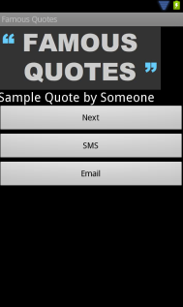

1. Go to **src** 🡪 **com.mindstorm.ex02** and open **MainActivity.java** file

The code to be placed is shown below:

**package** com.mindstorm.ex02;

**import** android.app.Activity;

**import** android.os.Bundle;

**import** android.view.View;

**import** android.view.View.OnClickListener;

**import** android.widget.Button;

**import** android.widget.Toast;

**public** **class** MainActivity **extends** Activity {

/** Called when the activity is first created. */

@Override

**public** **void** onCreate(Bundle savedInstanceState) {

**super**.onCreate(savedInstanceState);

setContentView(R.layout.*main*);

//Next Button

Button btnNext = (Button)findViewById(R.id.*btnNext*);

btnNext.setOnClickListener(**new** OnClickListener() {

@Override

**public** **void** onClick(View v) {

showToast("Get Next Quote");

}

});

//SMS Quote Button

Button btnSMS = (Button)findViewById(R.id.*btnSMS*);

btnSMS.setOnClickListener(**new** OnClickListener() {

@Override

**public** **void** onClick(View v) {

showToast("Launch SMS App");

}

});

//Email Quote Button

Button btnEmail = (Button)findViewById(R.id.*btnEmail*);

btnEmail.setOnClickListener(**new** OnClickListener() {

@Override

**public** **void** onClick(View v) {

showToast("Launch Email App");

}

});

}

**private** **void** showToast(String msg) {

Toast.*makeText*(**this**, msg, Toast.*LENGTH_SHORT*).show();

}

}

**Step 3 – Run the Example**

1. **Right Click** the **Project** in Eclipse.
2. Select **Run As 🡪 Android** Application
3. (Optional): If you have multiple compatible AVDs running, select the correct AVD. In our case it is the 2.3.3 AVD.

You should see the MainActivity screen come up as shown below:

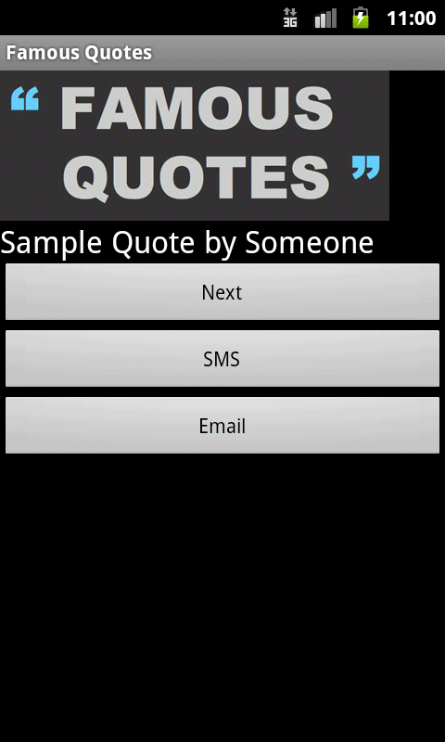

On clicking the Begin button, you should see the respective button click handlers getting fired. Currently they only show Toast messages.

**Summary**

This hands-on exercise demonstrated how you can use the Linear Layout to create the UI for an Android activity. The Layout can have multiple views within it. Event Handlers are written on the views so that the code that needs to be executed when the view is clicked (for example) is executed.